Jackets Youth Cheer Constitution
Cheer and Pom

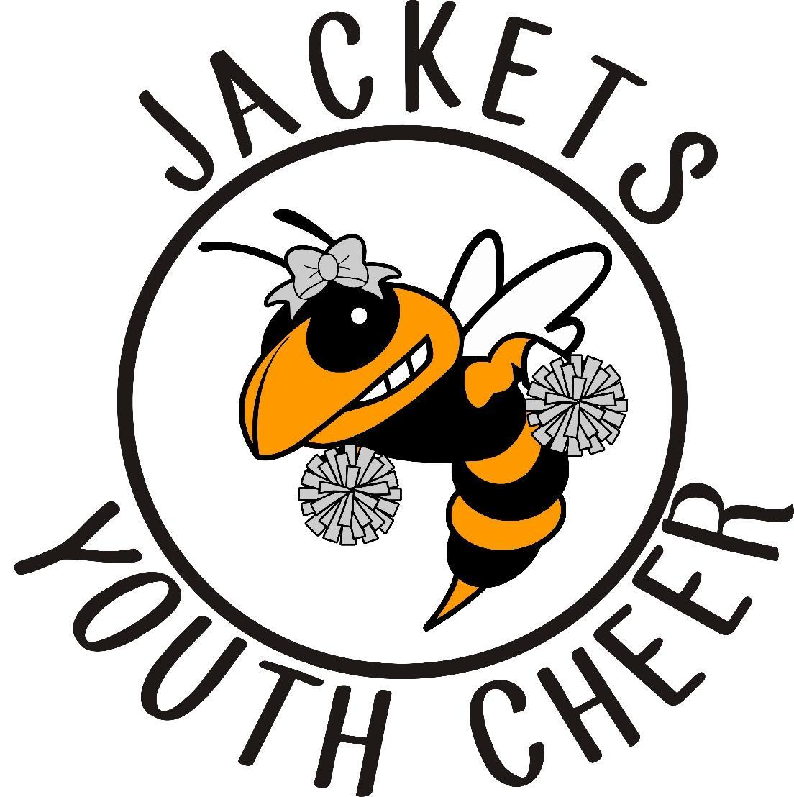

JACKETS YOUTH CHEER CONSTITUTION - BOARD APPROVED: March 2, 2024

Mission Statement

To provide the youth of Rockwall a fun, safe, encouraging and enriching cheer experience for kindergarten - 6th grade. Our goal is to teach participants the value of teamwork, sportsmanship, discipline, dedication, responsibility, and build the foundations and fundamentals of cheerleading so they are well equipped to advance to the next level of cheer.

JYC is committed to being an organization that communicates clearly and effectively while striving to be completely transparent every step of the way. This includes communication with RYCA Football, participants, parents, and the community.

Policies & Procedures

- This organization shall be known as Jackets Youth Cheer, herein referred to as “JYC”.
- JYC will provide a cheer program and a pom squad that teaches the fundamentals of cheerleading and dance.
  - JYC will be responsible for upholding all policies and procedures set forth herein and enforce the mission of JYC.
- JYC covers both the cheer and pom branches. All cheer references also cover pom.
- JYC Board Members (herein referred to as the “Board”) will consist of the Director and Assistant Directors.
  - The Board’s purpose shall be to uphold the policies and procedures set forth and to vote on all issues and policy changes presented.
  - The Board shall be vested in RYCA football
  - The Board shall be vested in Cheer Athletics Rockwall and MPACT Dance Studio
- Each member of the Board shall uphold the responsibilities they have for their positions and communicate with the Board their actions and ideas.
  - The Board has the right to remove a fellow board member from the board if it is determined by a vote that the affected member is not upholding their duties.
- It shall be the purpose of JYC to support and develop good relationships in the community and with RYCA football during all events and encourage team spirit.
- JYC shall strive to work in unity with other sporting organizations & our community.
  - All squads must comply with JYC, CA Rockwall, and MPACT Dance guidelines.

Legal Guardian Responsibilities

- Responsible for making sure their cheerleader attends mandatory events as scheduled.
- Transportation to and from practice, games, and events.
- Purchase required uniform package.
- Pay in full upon registration. There are no refunds unless there is an extenuating circumstance as approved by the Director. The maximum refund can be up to $150.
- Provide their child’s own refreshments when not provided by coaches.
- Adhere to the fundraising requirements as listed further in the constitution.
- Follow and uphold the JYC constitution.

Eligibility Requirements

- A candidate must support JYC, RYCA Football, CA Rockwall and MPACT Dance.
- A candidate must be medically cleared and have legal guardian’s permission.
- Acceptance of candidate shall be based on registration fees paid in full, code of conduct, and without prejudice of race or gender.
- A candidate may be female or male and must be enrolled in kindergarten‐6th Grade and not be more than thirteen years of age as of September 1st.

Cheer Squads

- The JYC Squads (herein referred to as “squads”) are divided by grade level.
- Cheer Squads can consist of a minimum of 8 members and a maximum of 26.
  - The squads may be co‐ed.
  - If a squad does not meet the minimum number or exceeds the maximum number, they will possibly be mixed with another grade level.
- Pom Squads can consist of a minimum of 8 members with no maximum.
  - The squads may be co-ed.
  - The squads will be broken into 1st/2nd, 3rd/4th grade and 5th/6th grade.
- Squads may cheer at games, clinics, camps, competitions, promotions, fundraisers, or community events as approved by the Board.
- Cheerleaders and legal guardians will honor and uphold the code of conduct.
- Cheerleaders and legal guardians will conduct themselves in a positive manner at all times while representing JYC.

Code of Conduct

- Squad members are to maintain and uphold a positive reputation of JYC.
- While in uniform or wearing any item of team identification; all cheerleaders, coaches, and parents will conduct themselves in a positive manner.
- All cheerleaders, legal guardians, family members, friends, and coaches are to be respectful at all times.
- All concerns or complaints should be addressed with the coach outside of cheer time.
- Any unsportsmanlike conduct may result in the removal from a game, practice, event or competition.
- Do not criticize anyone in front of others, but reserve constructive criticism for a one-on-one meeting.
- All cheers, chants, and dances will be positive, appropriate, and sportsmanlike.
- Squad members are not permitted to chew gum or have candy in their mouths during practices, games, or events.
- Cheerleaders and coaches will not be under the influence of alcohol, narcotics, performance enhancing substances or over the counter medications while participating in a practice or event that would hinder the ability to supervise or execute a routine safely.
- Squad members must participate in all aspects of practice.

Social Media

- Cheerleaders must respectfully portray themselves during the entire cheer season on any social media platform. Cheerleaders will not engage in bullying or inappropriate images, language, videos, music videos, or other inappropriate content. If a cheerleader is caught doing anything that is inappropriate, it will be submitted to the board’s attention, parents will be notified, and that cheerleader will be subject to consequences.
- Social media must NOT portray JYC, cheerleaders, coaches, parents, board members, RYCA, Cheer Athletics Rockwall, or MPACT Dance negatively. If the JYC Board or Coaches feel anyone that is a part of JYC organization has made a negative post or comment on any social media site that is directed towards JYC (league, coaches, parents, cheerleaders, or board member), that person will be subject to consequences.

Bullying

- JYC has a zero-tolerance policy for bullying. Bullying will not be allowed at any time during the cheer season. This includes outside of practices, games, and other JYC events. If a cheerleader shows unsportsmanlike conduct, the JYC Board will review the information, at which time a decision can be made to remove said cheerleader(s) from our program. JYC reserves the right to refuse a cheerleader to participate in any JYC activity. JYC has a zero tolerance for any drama, altercation, or verbal discrimination from any player, parent, coach, or board member towards another JYC member.

Attendance Requirements
- Cheerleaders must attend all practices, games, competitions, and events, unless pre‐approved by their head coach or Board.
- All cheerleaders are required to attend cheer camp as a squad; unless pre‐approved by the Board.
- All games and All practices are mandatory; unless pre-approved by the team sponsor or director.
- Absences must be communicated to the team sponsor in a timely manner.

Uniform Requirements
- Cheerleaders will wear specified attire as instructed by the team sponsor to all events.
- Cheerleaders will wear practice uniforms as instructed by the team sponsor.
  - Backpack should always contain practice items as required by the team sponsor.
- Cheerleaders will wear game day uniforms as instructed by the team sponsor.
  - Backpack should always contain game day items as required by the team sponsor.
- Only official squad jackets can be worn over uniform while cheering or attending a JYC event.
- No jewelry may be worn at games, events, or practices.
- All fingernails must be kept at an appropriate length to minimize risk of injury to cheerleaders.
- Hair to be worn as designated by the team sponsor for games and practices.
- Makeup is to be of a natural look and lipstick color will be determined by the team sponsor.
- Hard casts that are rough edged must be appropriately covered with a padded material that protects all cheerleaders from injury.
- Uniforms must be kept clean at all times.

Cheer Practice

- No cheer squad shall begin practice prior to the last week in July.
- Cheer Camp is MANDATORY.
  - Prior approval to miss cheer camp has to be approved by the Director.
    - Unapproved absence can result in removal from half-time routine.
- Outside of Cheer Athletics Rockwall and MPACT Dance practice, practice locations and times must be approved by the Director prior to commencement of first practice.
- Squads practice no more than 4 hours per week.
- Conditioning will be a part of cheer practice.
- Only squad members are to attend practice.
  - Parents may observe from the assigned location given by the coach or sponsor.
- Practice schedule shall be set by the coach or sponsor.
  - There will be no more than two practices a week Monday – Thursday.
- Tumbling and stunting is not permitted without coach and sponsor approval.
- When at Cheer Athletics Rockwall or MPACT Dance Studio, the squads will follow all rules set forth by the gym/studio and will be respectful of their time.

Game Day Requirements

- The JYC Board will provide the final cheer schedule to the team sponsors to release to parents.
- Squads must all be in the same uniform as determined by the team sponsors.
  - If not in proper uniform, cheerleaders may be required to sit out.
- The entire squad must cheer on the sideline for the entire game.
  - Squads may build stunts on the sidelines with coaches approval and sponsor supervision.
- The only time cheer will be canceled is if the football game is canceled.
- Girls must stay through the entire game, unless previously approved by the team sponsors.
- Any unsportsmanlike conduct will result in consequences.
- Half‐time cheer routines will be limited to five minutes per squad.
  - Including walk on, intro of each spirit girl, and the performance.
- Visiting squad shall be introduced and perform first then proceed to the sideline to watch the home cheer team perform.
  - JYC will support opposing team performance.
- At the beginning and end of the games, the squad will line up for a spirit tunnel.
- If a football player becomes injured during a game, both cheer squads are to stop cheering and kneel on one knee.
  - Once the injured player is removed from the field, the cheer squad should applaud.
- Legal guardians are not allowed on the field, hanging over the fence, talking to, or distracting their child from the stands.
- Snack distribution will be determined by the team sponsors.
- Only water is allowed during games.
  - No colored drinks or eating allowed while cheering.

Spirit Girl

- Each Squad can have one or more Spirit Girls per week. Spirit Girls will be the leader for that week’s game as selected by the coach or sponsors.
- Spirit Girl of the week is given recognition at that week’s game by being announced.
- Responsibilities of the Spirit Girl will be determined by the coach or team sponsors.

Competition

- Competition squads may be available for registered JYC members only.
  - Participation is optional.
- Squads will raise their own funds and/or pay additional fees for all competition events.
- Director will determine squad placement based on the skills required in the competition routine.
- Additional weekly practices will be mandatory and determined by the Director.
  - An absence will be excused only if approved by the coach in advance.
  - More than 2 unexcused absences can result in removal of the competition team without a refund.
- Competitions attended will be determined by the Director and/or Assistant Directors.

Fundraising

- All cheerleaders may participate in individual fundraising projects that directly benefit that cheerleader.
- JYC will schedule organizational fundraisers that a cheerleader can choose to participate in or buy out as designated by the set fee.
- All fundraising activities will be approved by the Board of Directors.
- All fundraising must be done before the first game of the season, or your child will not be able to participate at the game.

Team Sponsors

- Organizing and arranging schedules and events.
- Have all appropriate equipment necessary for games and events (Provided by JYC).
- Always dress appropriately.
- Lead by example and follow all rules and regulations of JYC.
- Act as a mediator for disagreements between cheerleaders in your squad.
- Must require proficiency before skill progression (Determined by CA/MPACT Coaches only).
  - Consider the cheerleader, group, and team skill levels.
- Be responsible for welcoming visiting squads and setting a good example of friendliness to other cheerleaders.
- Keep the crowd cheering and the squad in proper formation during games.
- No changes to cheers, chants, stunts or dance routines are allowed (Only CA/MPACT Coaches can make changes or additions).
- All cheerleaders must be supervised during all official functions by a qualified director, coach or sponsor.
- Ensures their squad does not perform or practice illegal skills.
- All stunts and tumbling may only be done on a flat and safe area.
- Sponsors supervising on game day must be listed on the squad's roster or approved by a director.
- Treat all cheerleaders, parents, sponsors and other coaches (football or cheer) fairly, equally, and with respect.
- Keep the cheerleaders off the playing field and within the defined sideline boundaries, as designated by RYCA Football.
- Each squad must be accompanied by at least one rostered sponsor on game day.
  - No squad should be on the field without an approved sponsor.
- If at least one rostered sponsor is not available, a member of the Board of Directors will be present or another grade sponsor.
- All sponsors must complete and pass a background check.
- Meet with Cheer Athletics Rockwall and/or MPACT Dance Studio to work together to implement expectations.

Consequences

- Failure to comply with the constitution will result in a written warning by the coach or team sponsors. If behavior continues a meeting will be conducted with the coach, sponsor and Director or Assistant Directors. Final meetings can result in removal of the cheerleader from the squad or from the half-time performance as deemed necessary by the coach and the Board of Directors.

Social Media Release
- I authorize and grant Jackets Youth Cheer (JYC) to take my photos regarding my experiences with them. I grant Jackets Youth Cheer to use my photos on Facebook, Twitter, Instagram, and other social media platforms. I allow Jackets Youth Cheer to edit, alter, copy, or distribute the photos for social media advertising and marketing. I agree that the photos belong to Jackets Youth Cheer. I understand that I will not receive any monetary compensation.

All decisions made by the JYC Board of Directors are final.

Jackets Youth Cheer Constitution

I have read and understand the Jackets Youth Cheer Constitution. By signing below, I agree to adhere to these rules and guidelines that are stated in this document. I also understand that going against the constitution, may result in removal from the cheer program.

Name of Athlete: ___________________________________________

Signature of Legal Guardian: __________________________________ Date: _____________

